*A service in memory of the life of*

Margaret Dunbobbin

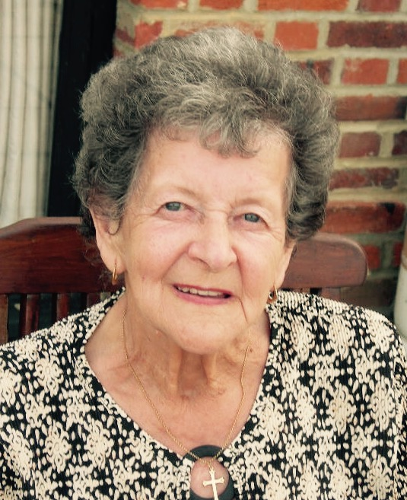

30th April 1926 – 9th December 2015

Thursday, January 7th, 2016

St Andrew’s Church, Orford, Warrington

2.00pm

*Service conducted by Revd Father Michael Raynor*

Order of Service

Opening Prayer

(All)

Heavenly Father,

in your Son Jesus Christ,

you have given us a true faith and a sure hope.

Strengthen this faith and hope in us all our days,

that we may live as those who

believe in the communion of saints,

the forgiveness of sins

and the resurrection to eternal life;

through Jesus Christ our Lord.

Amen.

Hymn

*‘The Old Rugged Cross’*

On a hill far away stood an old rugged cross,  
The emblem of suff’ring and shame;  
And I love that old cross where the Dearest and Best  
For a world of lost sinners was slain.

*Refrain*  
So I’ll cherish the old rugged cross,  
Till my trophies at last I lay down;  
I will cling to the old rugged cross,  
And exchange it someday for a crown.

Oh, that old rugged cross, so despised by the world,  
Has a wondrous attraction for me;  
For the dear Lamb of God left His glory above  
To bear it to dark Calvary.

In that old rugged cross, stained with blood so divine,  
A wondrous beauty I see,  
For ’twas on that old cross Jesus suffered and died,  
To pardon and sanctify me.

To the old rugged cross I will ever be true;  
Its shame and reproach gladly bear;  
Then He’ll call me someday to my home far away,  
Where His glory forever I’ll share.

Psalm 23

The Lord is my shepherd;

Therefore can I lack nothing.

He makes me lie down in green pastures

and leads me besides still waters.

He shall refresh my soul

and guide me in the paths of righteousness for his names sake.

Though I walk through the valley of the shadow of death,

I will fear no evil;

for you are with me;

your rod and staff they comfort me.

You spread a table before me

in the presence of those who trouble me;

you have anointed my head with oil

and my cup shall be full.

Surely goodness and loving mercy shall follow me all the days of my life,

and I will dwell in the house of the Lord for ever.

Glory be to the Father, and to the Son,

and to the Holy Spirit;

as it was in the beginning is now,

and ever shall be; world without end.

Amen.

Bible Reading

Family Tribute

*By Ian – Margaret’s Son*

Address Fr Michael

Prayers

*A prayer for the souls of Margaret, Frank and grandson Peter*

*A prayer for Ian and the family as they grieve*

*Together, we pray…*

The Lord’s Prayer

Our Father; who art in heaven,

hallowed be thy name;

thy kingdom come,

thy will be done,

on earth as it is in heaven.

Give us this day our daily bread

and forgive us our trespasses,

as we forgive those who trespass against us.

And lead us not into temptation,

but deliver us from evil.

For thine is the kingdom,

the power and the glory,

for ever and ever.

Amen.

A Poem for Nan

*Composed & Read By Nicola – Margaret’s Grand Daughter*

Hymn

*‘Love Divine, All Loves Excelling’*

Love divine, all loves excelling,

Joy of heaven to earth come down,

Fix in us thy humble dwelling,

All thy faithful mercies crown.

Jesus, thou art all compassion

Pure unbounded love thou art;

Visit us with thy salvation,

Enter every trembling heart.

Come, almighty to deliver,

Let us all thy grace receive;

Suddenly return, and never,

Never more thy temples leave.

Thee we would be always blessing,

Serve thee as thy hosts above,

Pray, and praise thee, without ceasing,

Glory in thy perfect love.

Finish then thy new creation,

Pure and spotless let us be;

Let us see thy great salvation,

Perfectly restored in thee;

Changed from glory into glory,

Till in heaven we take our place,

Till we cast our crowns before thee,

Lost in wonder, love, and praise!

Final Prayers and

God be in my head, and in my understanding;

God be in my eyes and in my looking;

God be in my mouth and in my speaking;

God be in my heart and in my thinking;

God be at my end and at my departing.

Amen.

The Blessing

There is a collection box at the Church exit doors.

At the family’s request, donations in memory of Margaret will go to

‘Walsingham Support’

supporting people with learning difficulties.

Ian and the family THANK everyone for coming today.

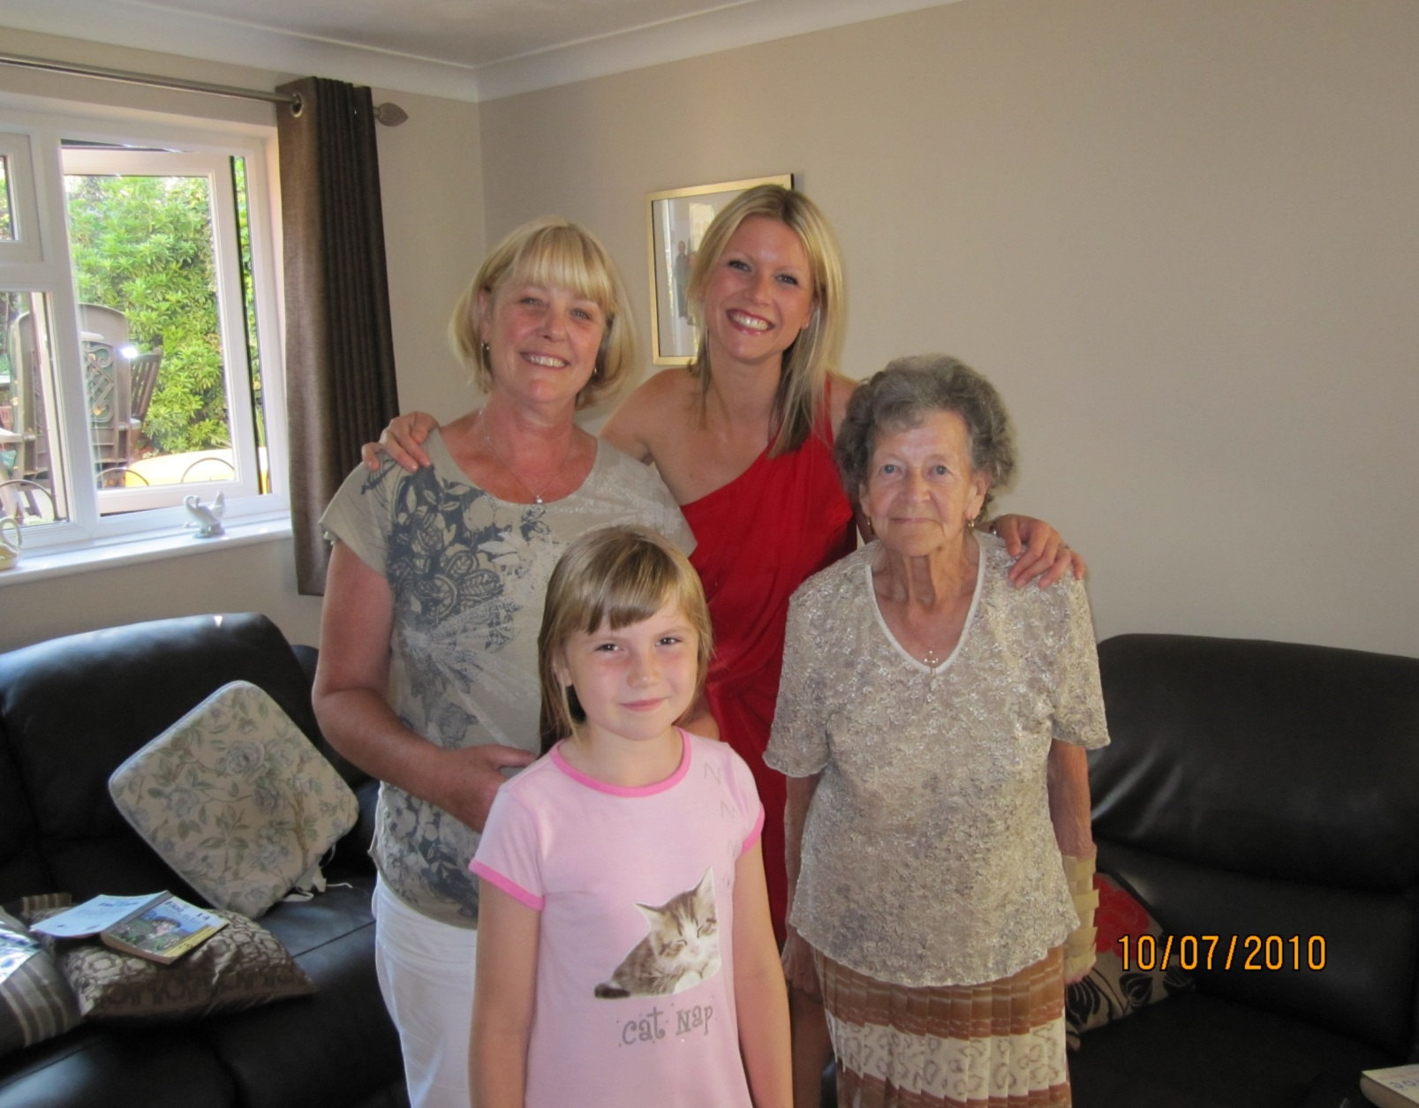

Donations in memory of Margaret

may be sent by cheque, payable to

Walsingham Support

*(Please put Margaret’s full name on the reverse)*

and send

**c/o Bennetts Funeral Directors**

2 High Street, Billericay, Essex, CM12 9BQ

Telephone: 01277 210104

